

<Draw It or Lose It>

# **CS 230 Project Software Design Template**

Version 1.0

## Table of Contents

**CS 230 Project Software Design Template**1

**Table of Contents**2

**Document Revision History**2

**Executive Summary**3

**Design Constraints**3

**System Architecture View**3

**Domain Model**3

**Evaluation**3

**Recommendations**5

## Document Revision History

| Version | Date | Author | Comments |
| --- | --- | --- | --- |
| 1.0 | 05/28/21 | Bryton Ondrejko | Added executive summary, design constraints, and description of the domain model. |

**Instructions**

Fill in all bracketed information on page one (the cover page), in the Document Revision History table, and below each header. Under each header, remove the bracketed prompt and write your own paragraph response covering the indicated information.

## Executive Summary

Creative Technology Solutions (CTS) needs a web-based application developed for their Android app titled Draw It or Lose It. We will be working to transfer all the relevant game functions from Android to work on a desktop environment.

## Design Constraints

Because the application will be web-based, functionality for mouse and keyboard must be included. Also, consideration for compatibility with different operating systems (Windows, OSX, Linux) will need to be factored in as well.

## System Architecture View

Please note: There is nothing required here for these projects, but this section serves as a reminder that describing the system and subsystem architecture present in the application, including physical components or tiers, may be required for other projects. A logical topology of the communication and storage aspects is also necessary to understand the overall architecture and should be provided.

## Domain Model

As shown in the UML diagram, the Entity class is our base class. GameService, Game, Team, and Player classes all inherit from Entity. This ensures that the sub classes can use all the functionality of the Entity class. Functions are included in the sub classes for adding teams and players, as well as creating new game IDs and names.

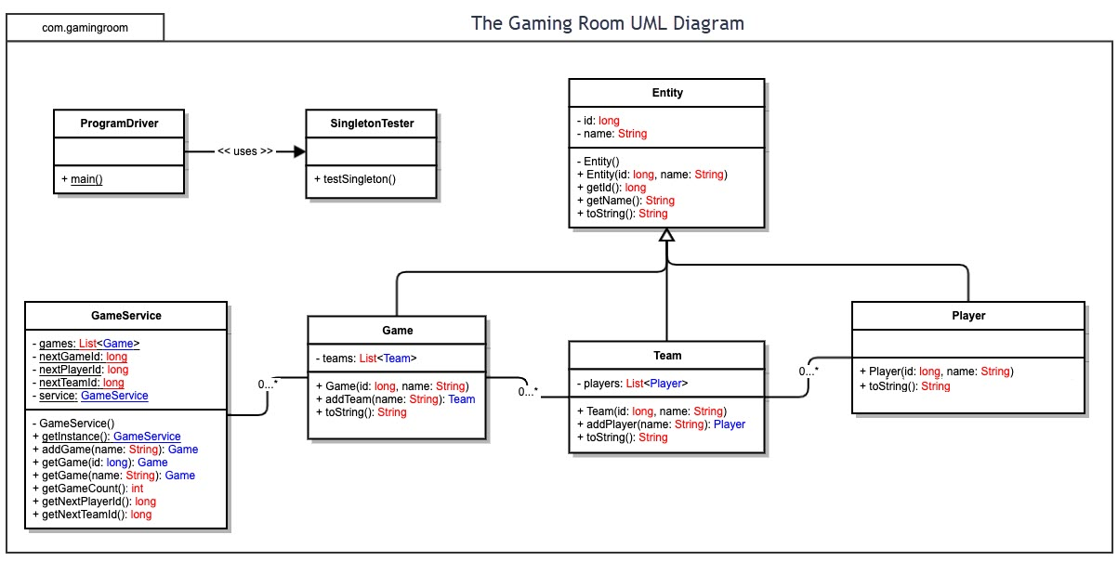

## Evaluation

Using your experience to evaluate the characteristics, advantages, and weaknesses of each operating platform (Linux, Mac, and Windows) as well as mobile devices, consider the requirements outlined below and articulate your findings for each. As you complete the table, keep in mind your client’s requirements, and look at the situation holistically, as it all has to work together.

In each cell, remove the bracketed prompt and write your own paragraph response covering the indicated information.

| **Development Requirements** | **Mac** | **Linux** | **Windows** | **Mobile Devices** |
| --- | --- | --- | --- | --- |
| **Server Side** | Macs have streamlined a lot of the process for developers. OSX programs work cleanly together without conflict. | Linux has the advantages of being open-source and free, which would eliminate licensing costs. | Microsoft has their own servers for offering web-based deployment, and hardware for windows is usually cheaper than Mac. | Mobile devices rely a lot on either Android or Apply operating systems. This platform would be the weakest for hosting a server on and would likely incur additional costs. |
| **Client Side** | Mac has the advantage, in this case, of not allowing modifications to their devices. This ensures all client hardware will be equal. Safari is native to Mac and will need to be considered. | Linux has a lot of the same considerations as PC and has historically been the most difficult platform to use for gaming. | Client PCs will vary wildly in terms of hardware availability. This makes developing more complicated because multiple combinations of hardware need to be considered. A variety of different web browsers exist on Windows as well. | The largest mobile OSs are Android and IOS. This, like Mac, is an advantage in making sure hardware requirements remain consistent. |
| **Development Tools** | Mac has emerged as the dominant platform for developers recently. The wide array of software available for Mac ensures compatibility with different programs will be easy. | Many cross-platform IDEs do not include Linux based on my research. | Windows is the most popular OS, and because of that, would have the most developers ready to work on a project. | Mobile devices have their own suite of development tools. Programmers need to be trained in developing for mobile devices specifically. |

## Recommendations

Analyze the characteristics of and techniques specific to various systems architectures and make a recommendation to The Gaming Room. Specifically, address the following:

1. **Operating Platform**: My recommended operating platform is Game Lift hosted by Amazon Web Services.
2. **Operating Systems Architectures**: Game Lift uses a cloud server in order to host Draw it or Lose It remotely. This solution supports cross play between all different platforms to ensure maximum compatibility.
3. **Storage Management**: 50 gigabytes of SSD storage are included with Game Lift, with more being available to purchase to satisfy any storage needs that would arise. Hosting some data on local servers would work as well, and Game Life promises compatibility with this.
4. **Memory Management**: Player and user information would be hosted and maintained through AWS.
5. **Distributed Systems and Networks**: Cross-play between platforms is supported natively through Game Life. The most obvious issue is the reliability on Amazon’s servers. Because everything is hosted through AWS, Draw it or Lose It would most likely go down if Amazon began having trouble with their servers.
6. **Security**: Game Life comes with security features in the base product. DDoS protection makes sure Draw it or Lose It is protected from any nefarious individuals trying to crash the server, while Amazon Cognito is used for safe and secure handling of user authentication.